Christopher Bermodes
Professor Samuel Addington
CECS 478 section 01
November 16, 2025
Final Project Report: Tamper-Evident Logs
Problem statement:
In this digital age, companies, organizations and governments heavily rely on digital logs for monitor operations, detection of threats and maintain accountability through critical systems. However, most companies, organizations and governments are still vulnerable to cyber-attacks targeting those logs by external attackers, malicious insider threats and advance malware. Once a malicious actor can access sensitive logs the malicious actor can steal, modify or make fictious logs to prevent detection. One of the most recent examples of this is the cyber-attack on SolarWinds in 2020 where manipulated security logs prevented detection by government analysts.
This recent example shows that traditional logging systems cannot be fully trusted in the places where attackers can control parts of a system. This is where Tamper-Evident Logs can assist with this problem. With tamper-evident logs organizations can reconstruct security incidents, validate incident timelines and hold people accountable for modifying or deleting digital logs. Additionally, tamper-evident logging systems can detect unauthorized modifications towards logs and provide a record of system activity.

System Design:
This project’s primary purpose is to implement event-tampering logs within a simulated messaging network where the client has a direct connection to the server. The structure and network design was used from CECS 478 Lab assignments four and five. Additional code objects were implemented in C coding language to achieve the primary objective.
This project consists of five critical components. The first component is the TLS client where it simulates a client by sending authenticated and encrypted messages directly to the server using TCP and TLS. The second component is the TLS Server. This project component accepts the client’s messages, where it then logs communication and message events towards the server and appends them to a tamper-evident log. This is all accomplished with the third component, the Hash Logger Module in the file hash_logger_build_1.0.c. The TLS server calls this file with its associated header file where it implements SHA-256 hash chaining, makes an append-only binary log, and creates a persistent chain-head. The fourth major component is the verification tool, where it recomputes the hash chain to detect any modifications to the event log. The fifth major component is the insider attack tool. This tool simulates a malicious insider that alters the event log directly without updating the hashes.
The protocols used for this project are TLS 1.3, Hash-chaining, binary logs and created offline tools such as the verifier tool and insider tool. The utilization of TLS 1.3 made sure that there was encrypted client to server communication as well as protection against MITM attacks. The use of Hash-chaining made sure any modification in the log breaks the chain during verification making an obvious sign of tampering. Binary logs were used for structural consistency and parsing reliability. Finally, the use of offline tools ensures independence from the logging system and enables forensic workflows
Threat Model:
Assets:
- Integrity of the event log
- Accuracy of recorded messages
- Hash chain continuity
- TLS-secured communication
Adversaries:
- External Attackers
- Malicious Insider
- Passive observers
  - Mitigated with the use of TLS to prevent packet sniffing
Assumptions:
- Server private key is protected
- File system has restricted access, however insider-level access is possible
- Attackers cannot make SHA-256 collisions to replicate hashes in a feasible timeframe
Risks:
- Current system is not protected against Denial-of-Service attacks
- Full log truncation cannot be detected without signed chain-heads
- Physical access to server may allow for full log deletion
Methods:
This system was implemented using the coding language C inside the class CECS 478 provide Docker environment. In this environment three components were developed. The first one was a secure communication layer using TLS. The workflow was primarily based on lab assignments 5, where the server loads the server.crt and server.ky to authenticate itself to client to encrypt the communication session. The second component was a tamper-evident logging module. This was accomplished with hash_logger_build_1.0.c, using SHA-256 from OpenSSL libcrypto library. The logger stores records in an append-only binary file called tamperlog.bin that contains:
- Sequence Number
- Timestamp
- Client IP
- Message payload
- Hash of the previous entry
- Hash of the current entry
Hashes were calculated as:
Curr_hash = SHA(prev_hash || header_fields || message)
The file prev_hash.bin stores the latest chain head for efficient appending of logs. The third component was verification and attack simulation tools. The tool verify_log recomputes the hash chain from the beginning and detects any differences caused by tampering. The tool read_logs parses and prints the binary logs in human readable language for additional analysis. Finally, the insider tool is used to simulate a malicious insider that modifies the log file without updating the hashes.
All experiments were conducted inside a Docker image that was provided to the class. The Initial workflow was done manually by first compiling all necessary files and activating three separate terminals. Terminal one would host the server listening for the client, terminal 2 would then activate the client to initiate communication between the client and server, and terminal 3 would monitor network traffic using tcpdump. Then manual deployment of verify_logs tool, insider tool and then verify_logs tool again were done to conduct tampering experiments and done multiple time to determine measurement detection accuracy.
Later, the implementation of a Makefile would reduce the workflow by first compiling the entire system by using the “make up” command, which build the server, client, logger, verifier, insider tool, and testing programs. After that controlled alpha and beta test were conducted using the command “make alpha” and “make beta” respectively. To reset logs for a fresh test, the command “make reset” was issued to remove the current tamperlog.bin and prev_hash.bin. Later, a “make demo” command implement to automate a general test that was conducted manually. Additional details for the demo can be found in the Architecture README where it shows the vertical flow of work done. After all tests were conducted the “make clean” command was issue to remove any compiled objects and logs to reset the system before the “make up” command.
Alpha tests consisted of two tests A1 – Happy path test and A2 – Negative test: Insider modification.
A1 – Happy path test
Server launch TLS handshake is conducted log generation verification of logs
The following were verified in this test:
- TLS handshake correctness
- Log entry creation
- Hash chain continuity
- Verification success
- No false detection
A – 2 Negative Test: Insider Modification
Logs entries were intentionally altered using the insider tool. This was to show if verification was to fail due to hash mismatch. Results show verification did fail and modification of logs has been detected.
Beta tests consist of 3 tests labels B1 through B3.
B1 – test_hash_logger
This test program writes multiple log entries using the logger module and confirms:
- Correct file growth
- Correct file structure formatting
- Correct computation of curr_hash
- Appending logs without corruption
B2 – test_verify_log
This test loads a clean log and tampered log that verifies:
- Clean logs get accepted
- Modified / tampered logs get rejected
B3 – Missing file
This test attempt makes the verification tool run on a non-existing log file. Program was expected to fail and generate a missing file error, which occurred.
The metrics collected in this project are:
Integrity Metrics
- Verification success / failure counts
  - Measured whether a log was intact or tampered
- Hash chain end values
  - Final SHA-256 hash was used to confirm chain continuity
Tampering Detection Metrics:
- Ability to detect
  - Message modification
  - Incorrect chaining
Operational Metrics
- TLS handshake completion
- Client-server message delivery success
- Good shutdown behavior
Results:
Test | Result
TLS Handshake | Successful
Clean log verification | Successful
Modified log verification | Successful / Detection occurred
Deletion attack on log | Not tested / testing ongoing
Insertion attack on tamper-evident log | Not tested / testing ongoing
ALPHA tests | All successful
Beta Tests | All successful

The use of TLS communication using tcpdump:
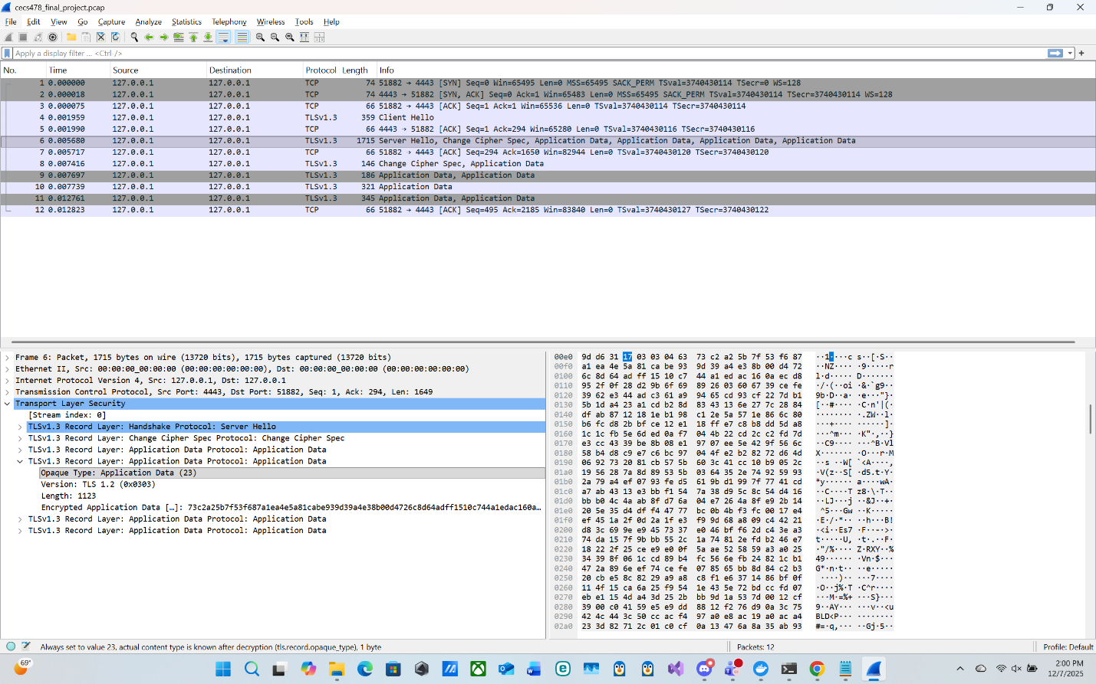
ALPHA test output / results:
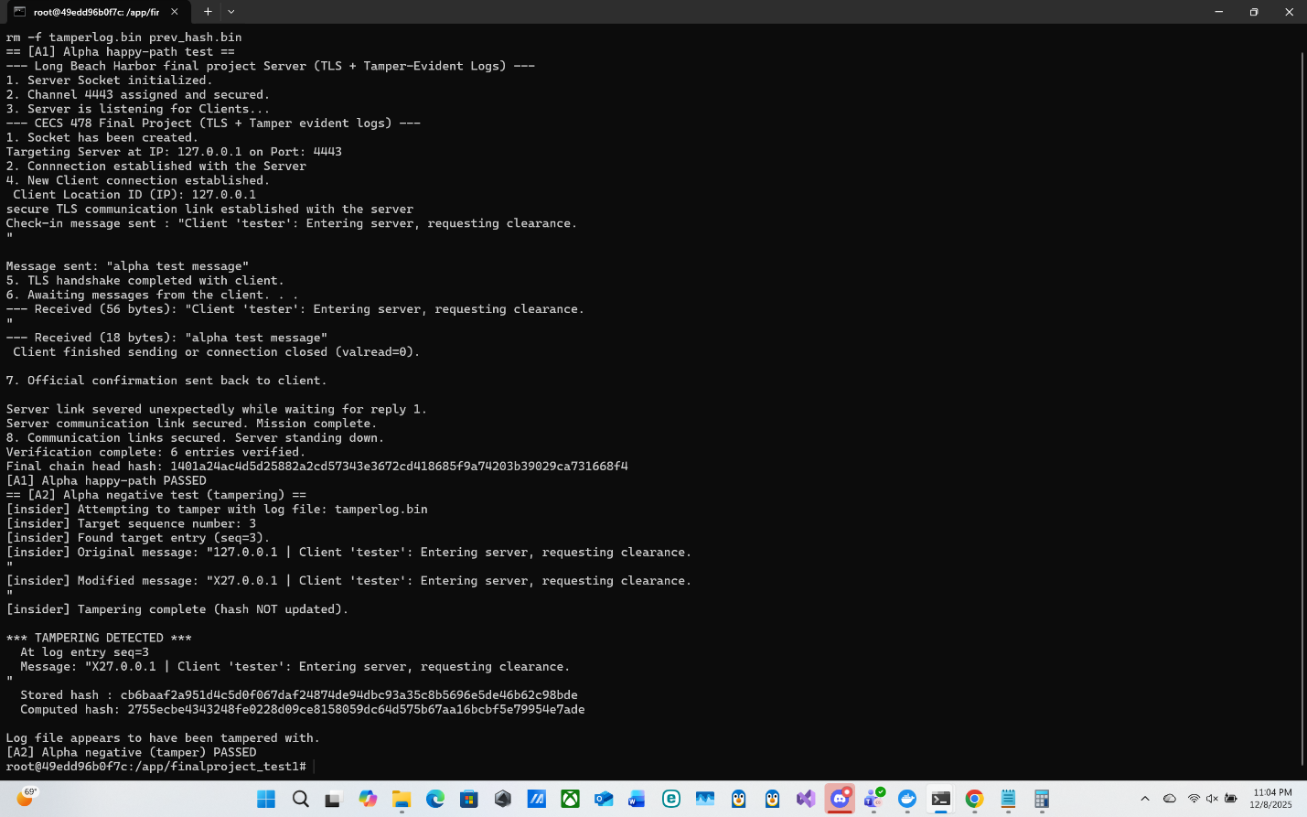
BETA Test output/ results:
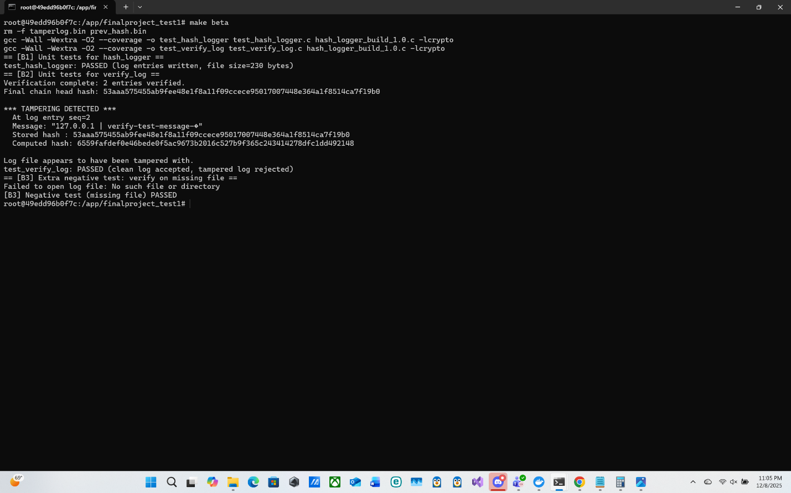

Limitations:
With this current build, the implemented system has been only tested against log manipulation attacks. Additionally, the hash logger module makes the IP address of the client a part of the message payload. This makes modification and tampering of the IP address records possible. Another limitation in the current build is if an attacker deletes both the tamperlog.bin and prev_hash.bin the current build cannot detect this attack. This current build does not have real time detection of any attack. Verification tools must be activated manually for any detection to occur.
Future Work:
For the future work for this project, there is additional testing against log deletion and insertion. Hash chaining of event logs should inherently detect these attacks; however, further testing is required to confirm this assumption. Additionally stronger attack models would be tested to see if the current system can detect timestamp manipulation as well as header tampering. Another feature that can be added in the future is real time detection of modification of logs and multi-client support. Additionally log rotation can be implemented in the system for better scalability and signed chain-head snapshots to prevent truncation and roll back attacks.

